THE GEORGE WASHINGTON UNIVERSITY

Department of Computer Science

CS 6554 - Computer Graphics II - Spring 2015

Lab 3

Shading and Illumination Modeling

Fei Yan

[hcifaye@gwu.edu](mailto:hcifaye@gwu.edu)

Case1: Constant Shading, Gourand Shading and Phong Shading (from left to right)

File: better-ball.d

Parameters:

|  |  |  |
| --- | --- | --- |
| Camera position = {0, 0, 0}; | Light position = {-1, 2, 2}; | ball1 position = {-2, 0, -4}; |
| Project reference = {0, 0, -1}; | Eye position = {0,1,5}; | ball2 position = {0, 0, -4}; |
| Up vector = {0, 1, 0} | Light Color = {1.0,0.75,0.8}; | ball3 position = {2, 0, -4}; |
| Near plane = 10.0; | Kd = 0.4 | Ball1 Constant Shading |
| Far plane = 200.0; | Ks = 0.6 | Ball2 Gourand Shading |
| Height = 10.0; | Ka = 0.5 | Ball 3 Phong Shading |

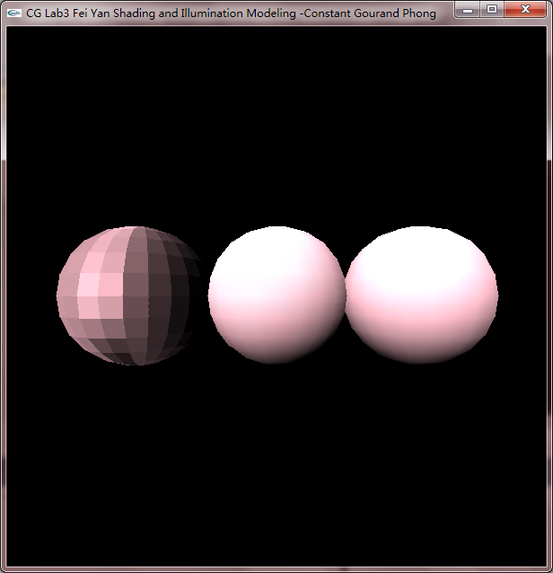

Case2: Constant Shading

File: better-ball.d

Parameters:

|  |  |  |
| --- | --- | --- |
| Camera position = {0, 0, 0}; | Light position = {-1, 2, 2}; | ball1 position = {0, 0, -2}; |
| Project reference = {0, 0, -1}; | Eye position = {0,1,5}; |  |
| Up vector = {0, 1, 0} | Light Color = {1.0,0.75,0.8}; |  |
| Near plane = 10.0; | Kd = 0.4 | Ball1 Constant Shading |
| Far plane = 200.0; | Ks = 0.6 |  |
| Height = 10.0; | Ka = 0.5 |  |

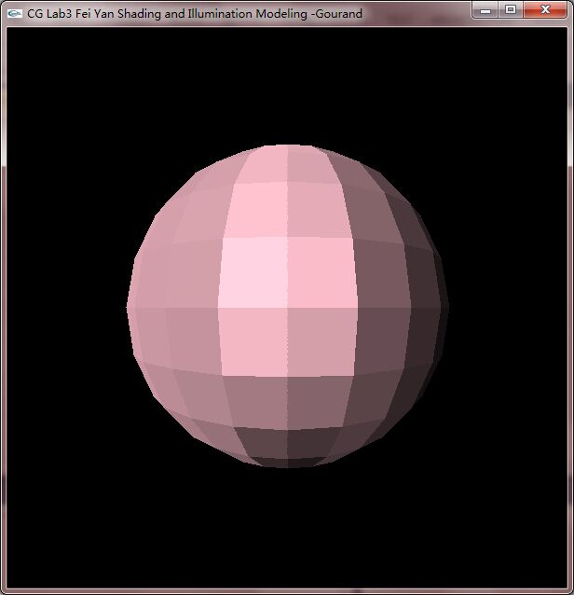

Case3: Gourand Shading

File: better-ball.d

Parameters:

|  |  |  |
| --- | --- | --- |
| Camera position = {0, 0, 0}; | Light position = {-1, 2, 2}; | Ball2 position = {0, 0, -2}; |
| Project reference = {0, 0, -1}; | Eye position = {0,1,5}; |  |
| Up vector = {0, 1, 0} | Light Color = {1.0,0.75,0.8}; |  |
| Near plane = 10.0; | Kd = 0.4 | Ball2 Gourand Shading |
| Far plane = 200.0; | Ks = 0.6 |  |
| Height = 10.0; | Ka = 0.5 |  |

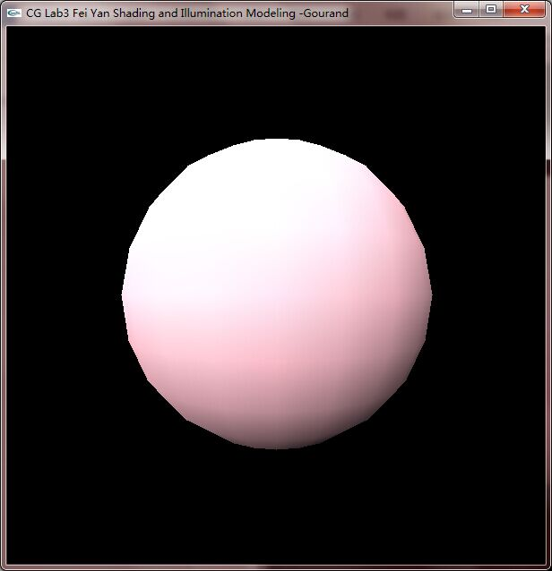

Case4: Phong Shading

File: better-ball.d

Parameters:

|  |  |  |
| --- | --- | --- |
| Camera position = {0, 0, 0}; | Light position = {-1, 2, 2}; | Ball3 position = {0, 0, -2}; |
| Project reference = {0, 0, -1}; | Eye position = {0,1,5}; |  |
| Up vector = {0, 1, 0} | Light Color = {1.0,0.75,0.8}; |  |
| Near plane = 10.0; | Kd = 0.4 | Ball3 Phong Shading |
| Far plane = 200.0; | Ks = 0.6 |  |
| Height = 10.0; | Ka = 0.5 |  |

